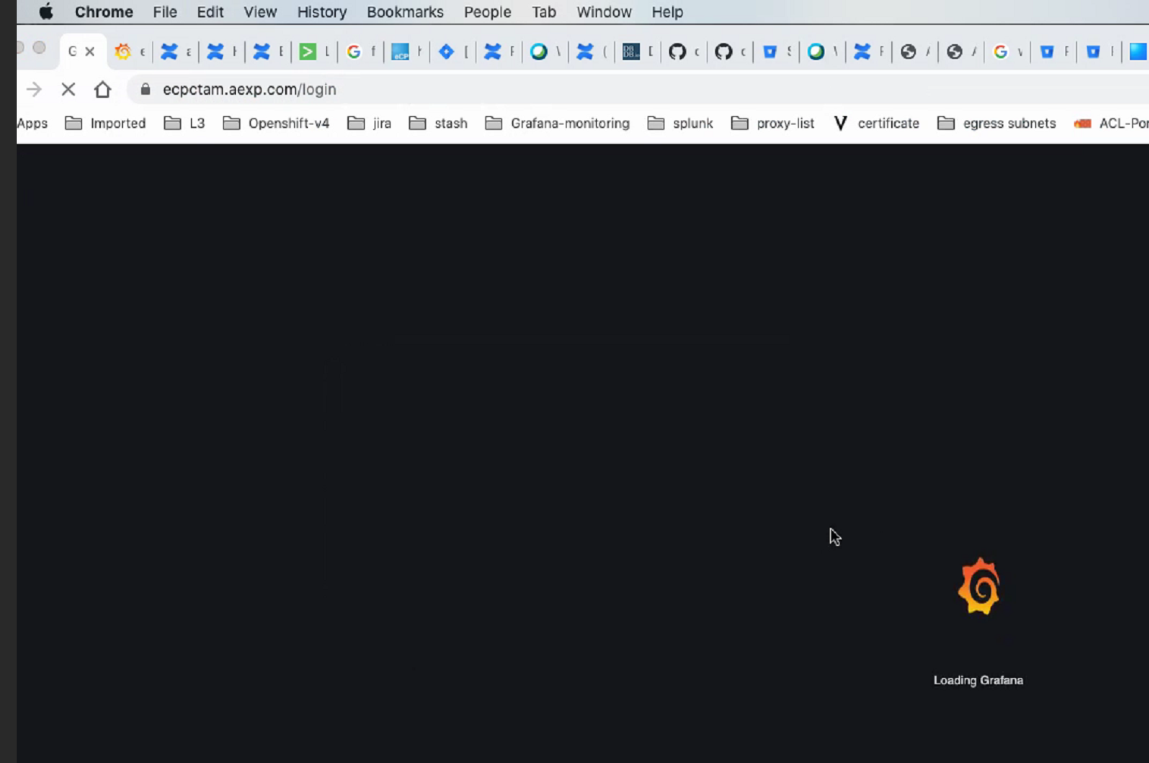

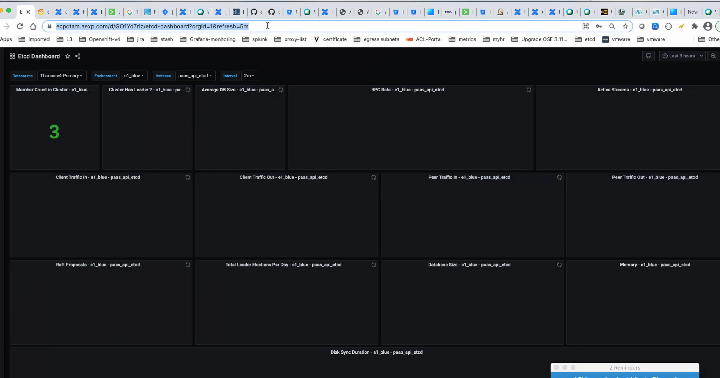

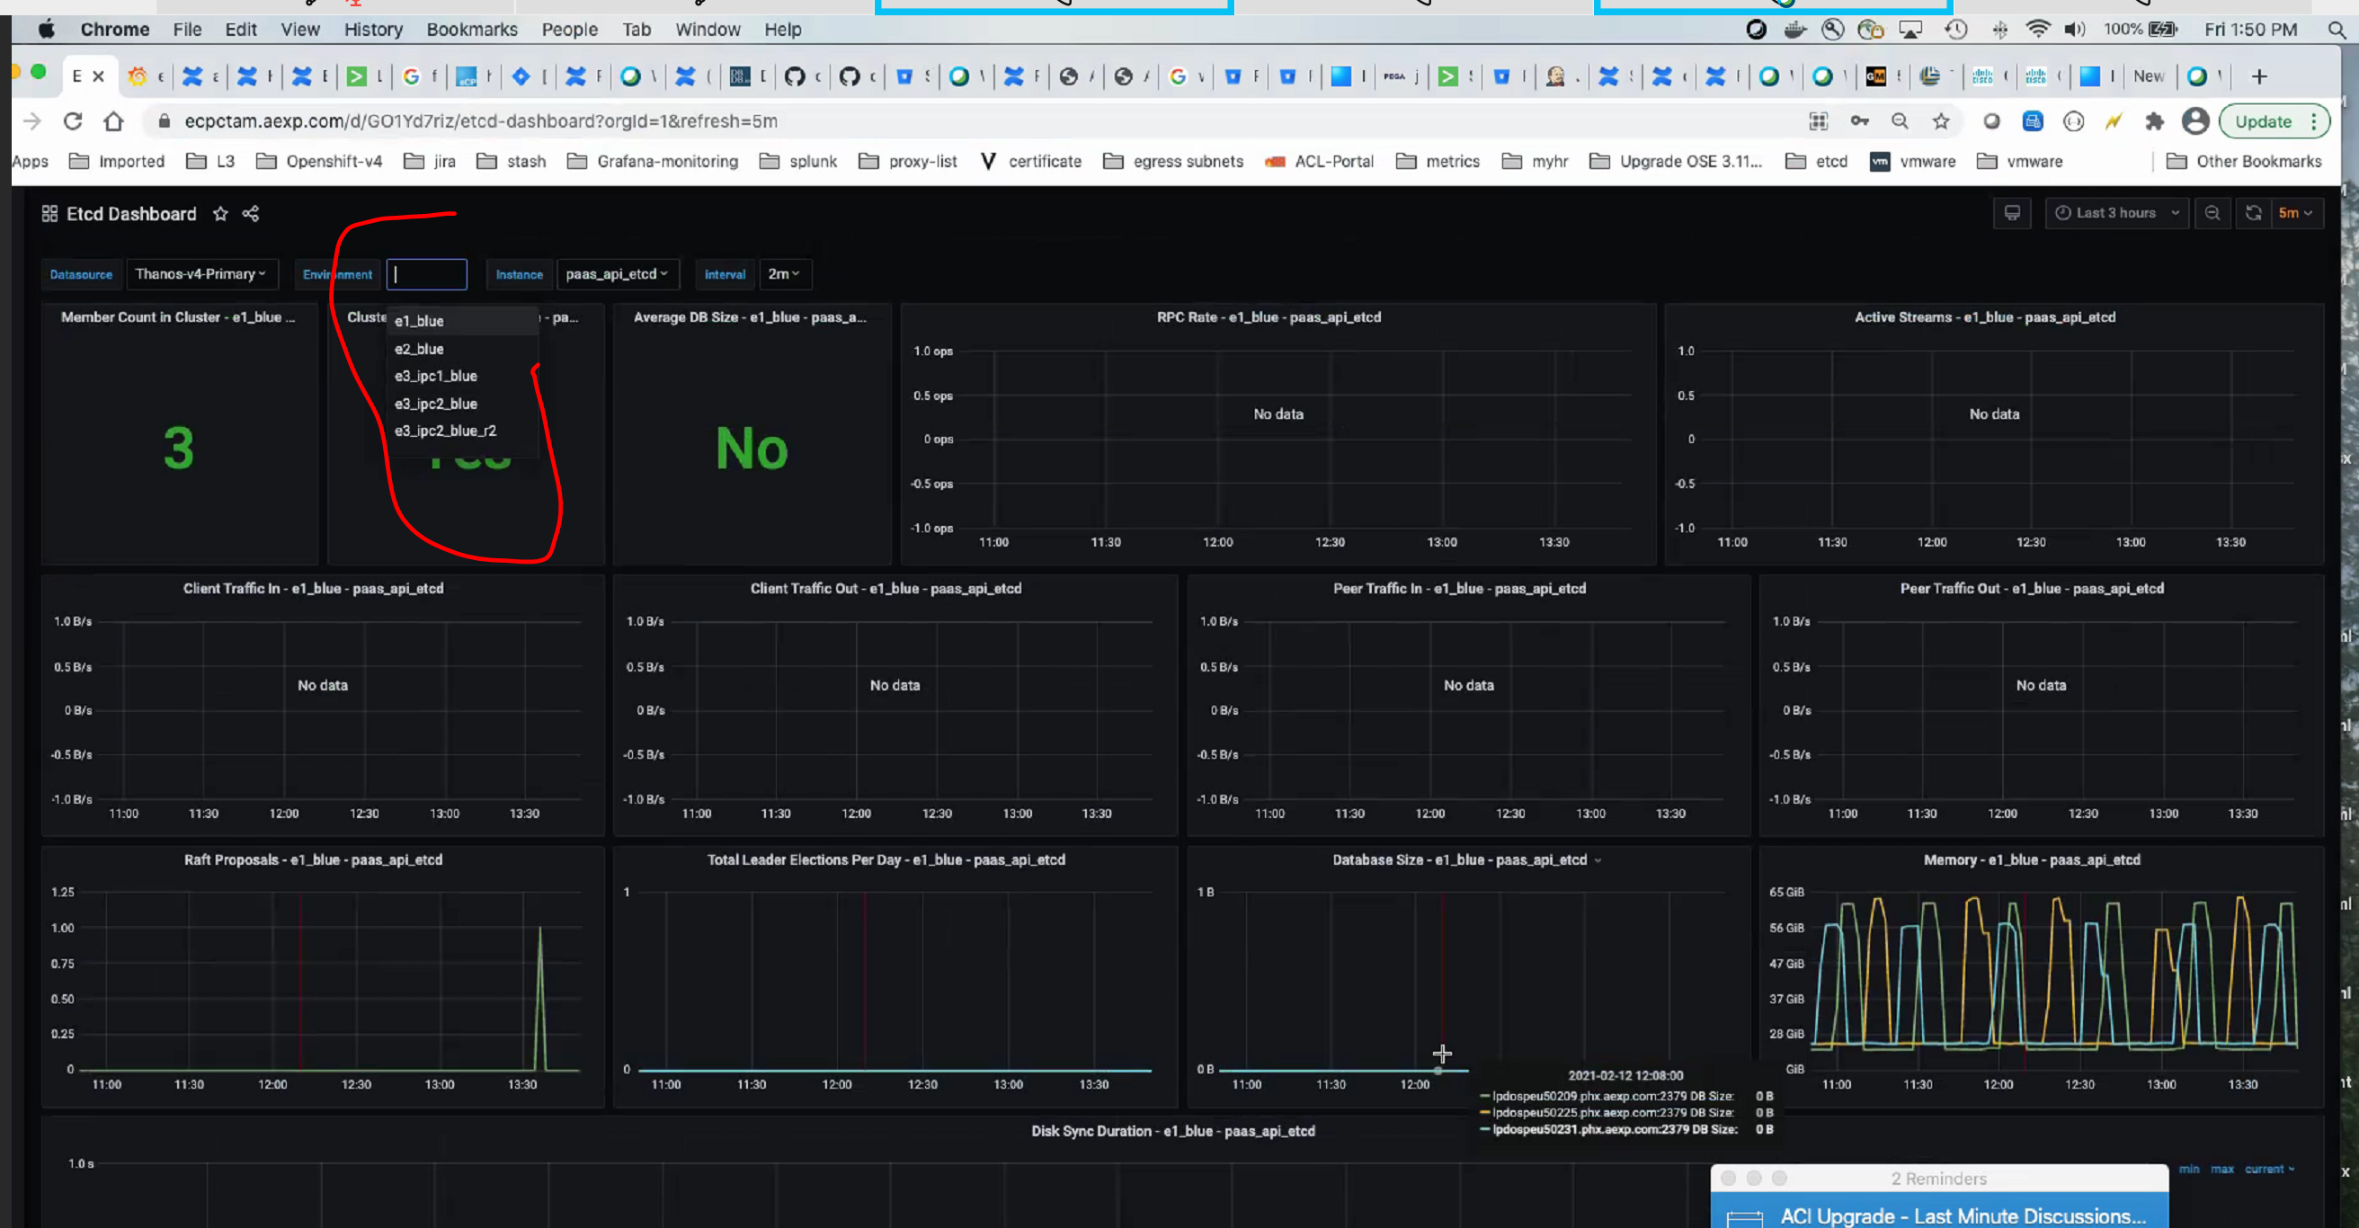

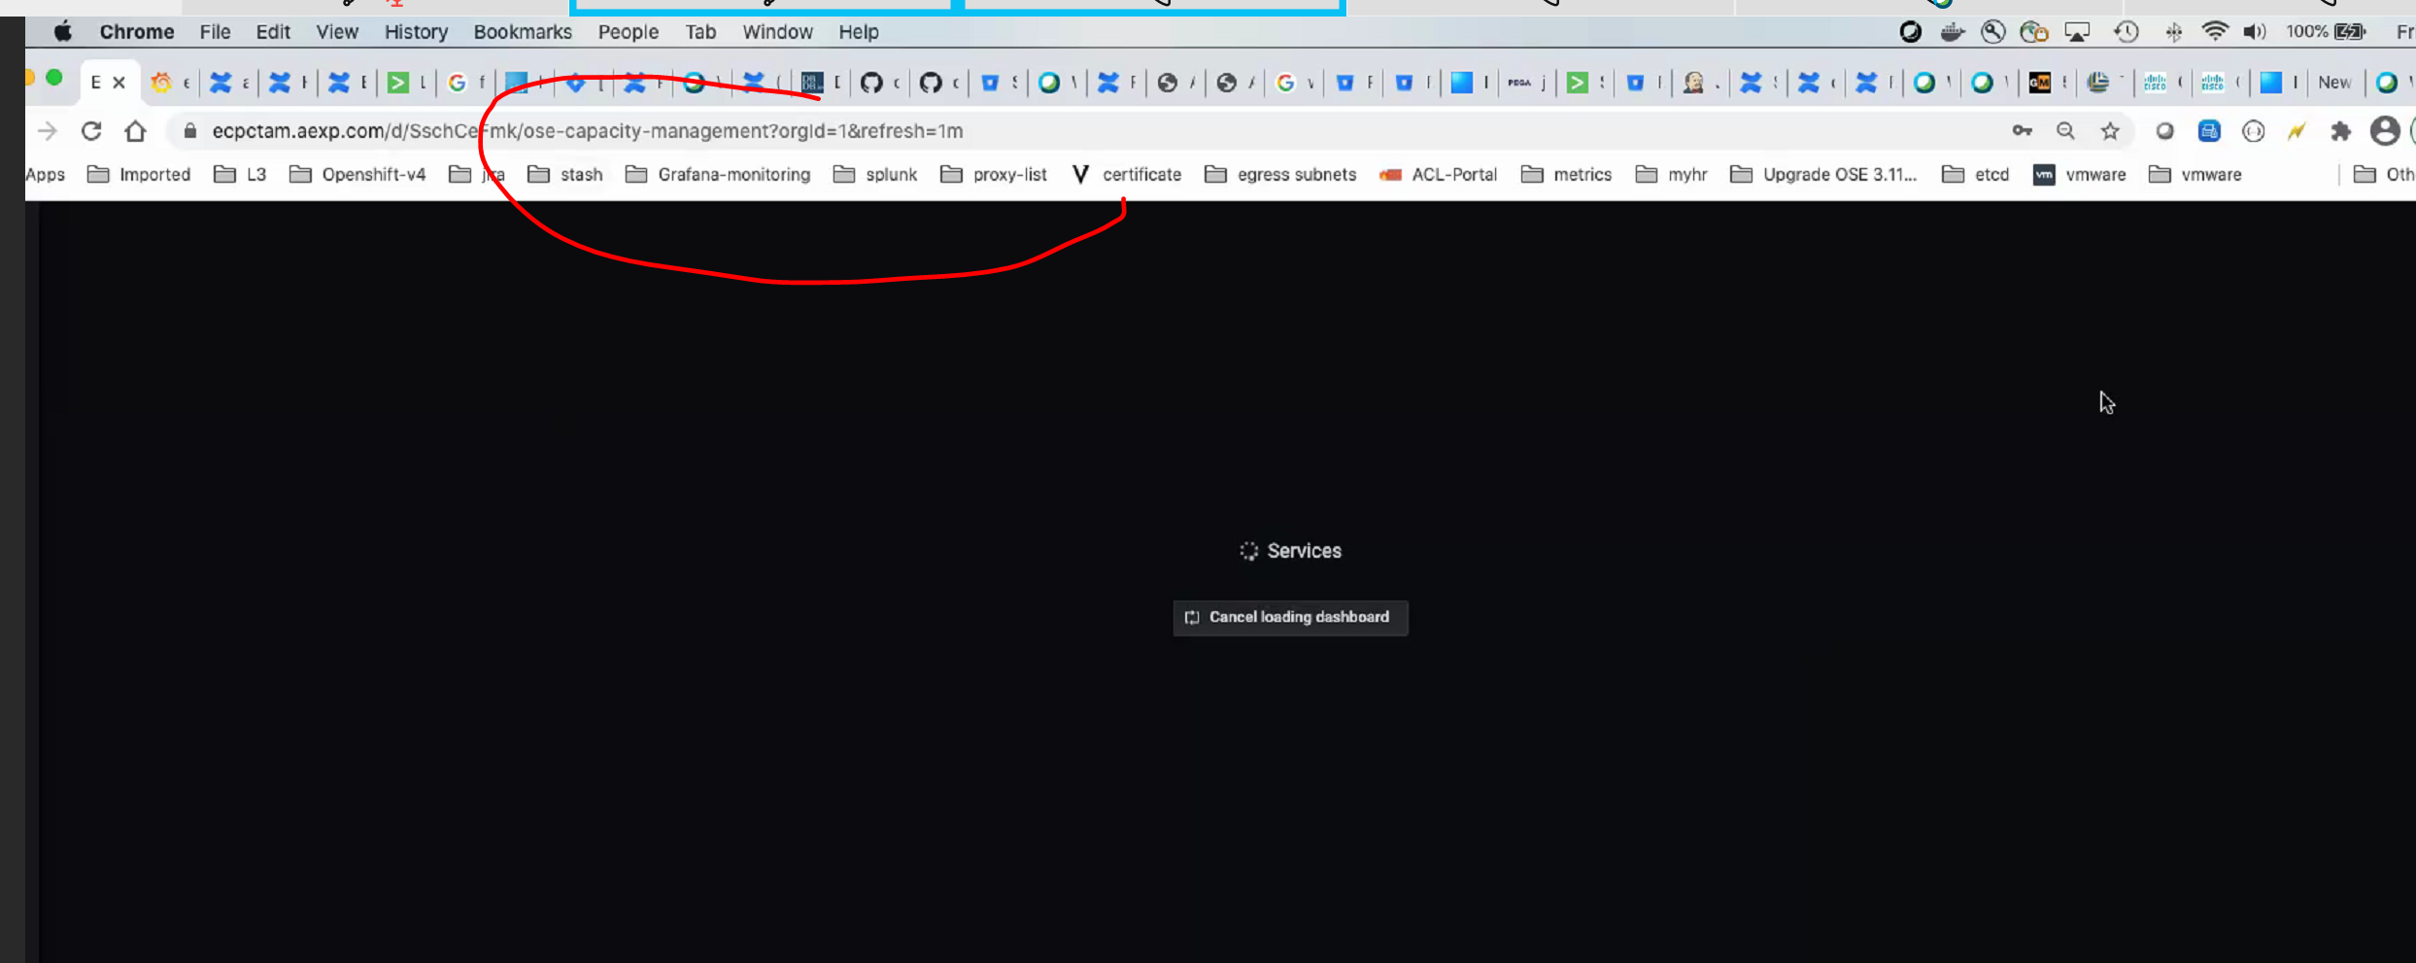

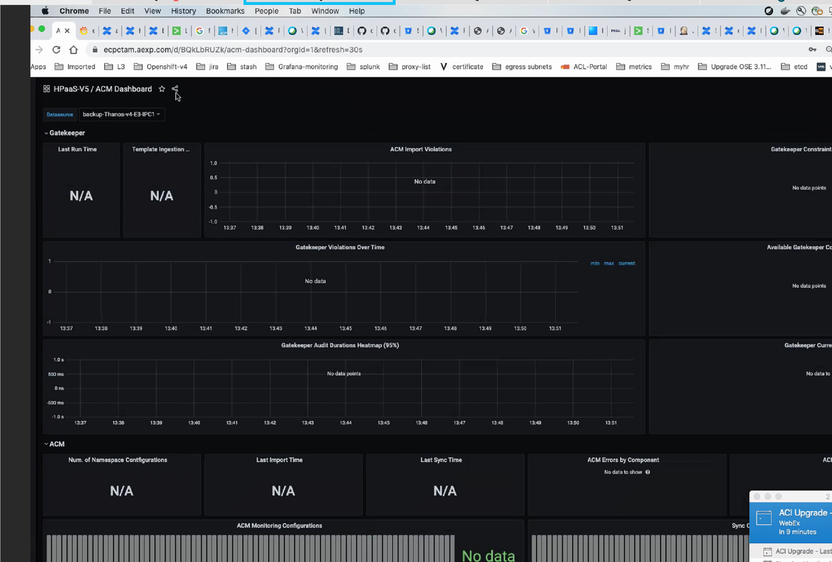

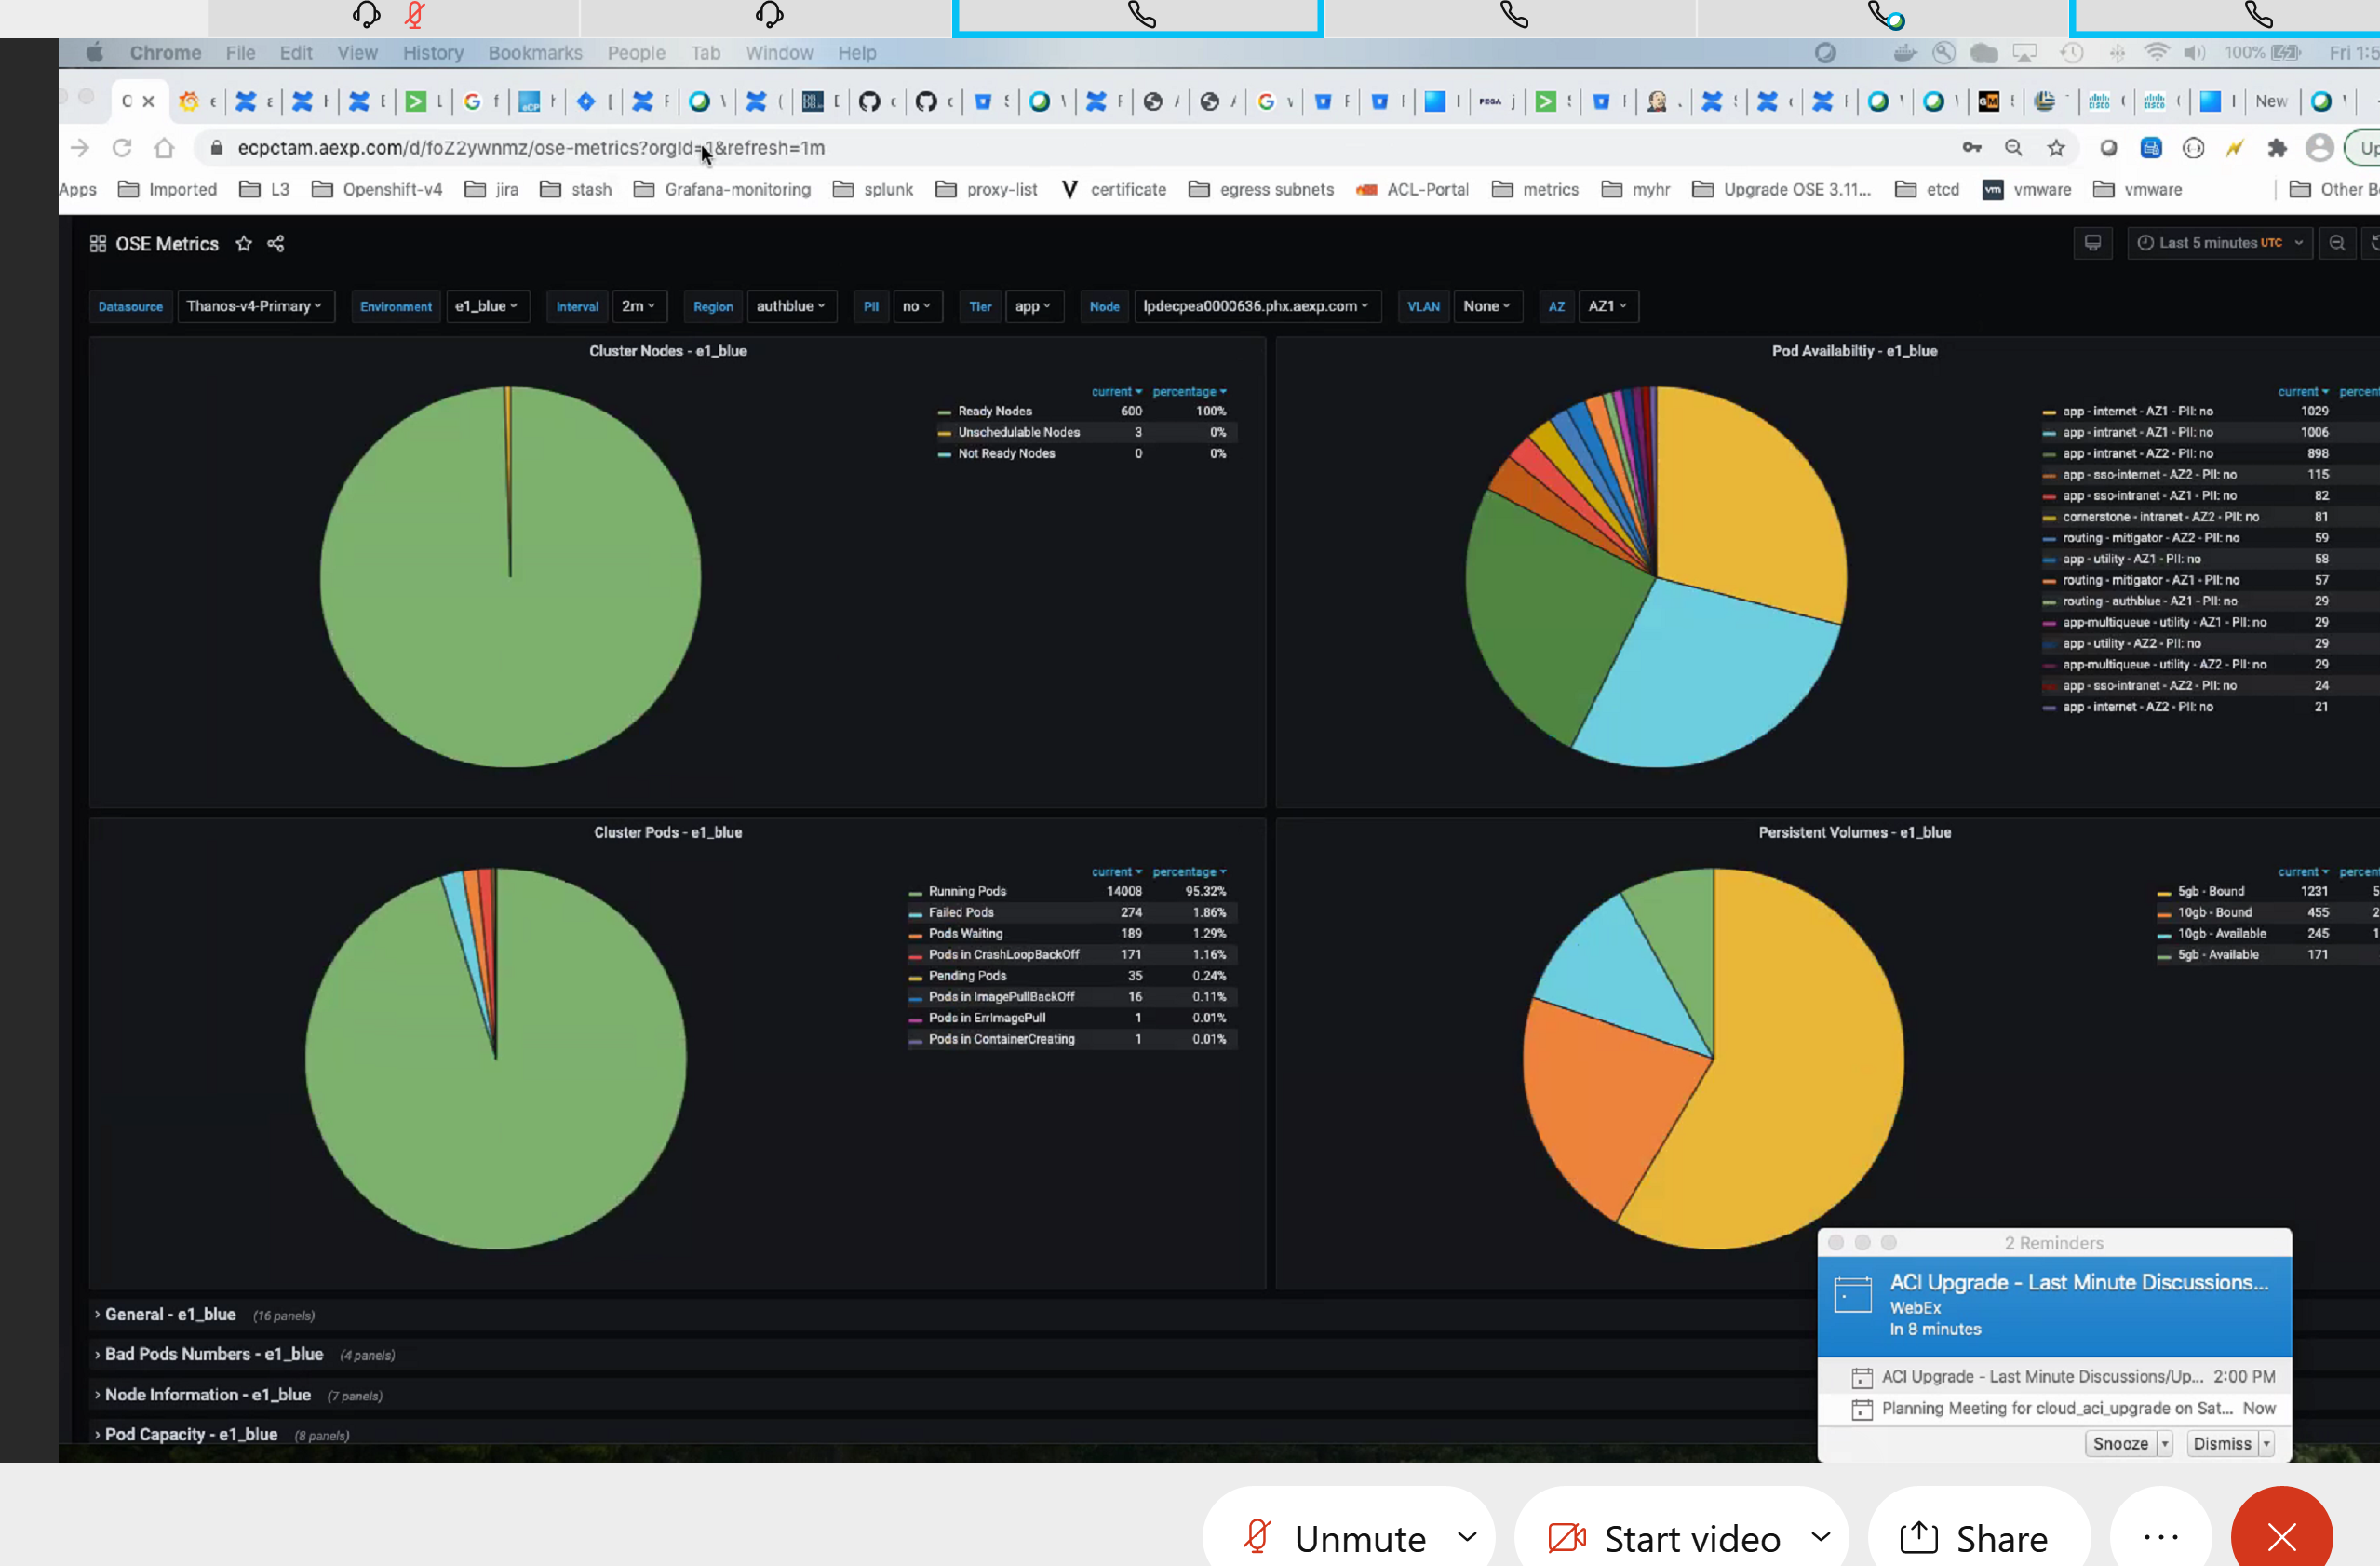

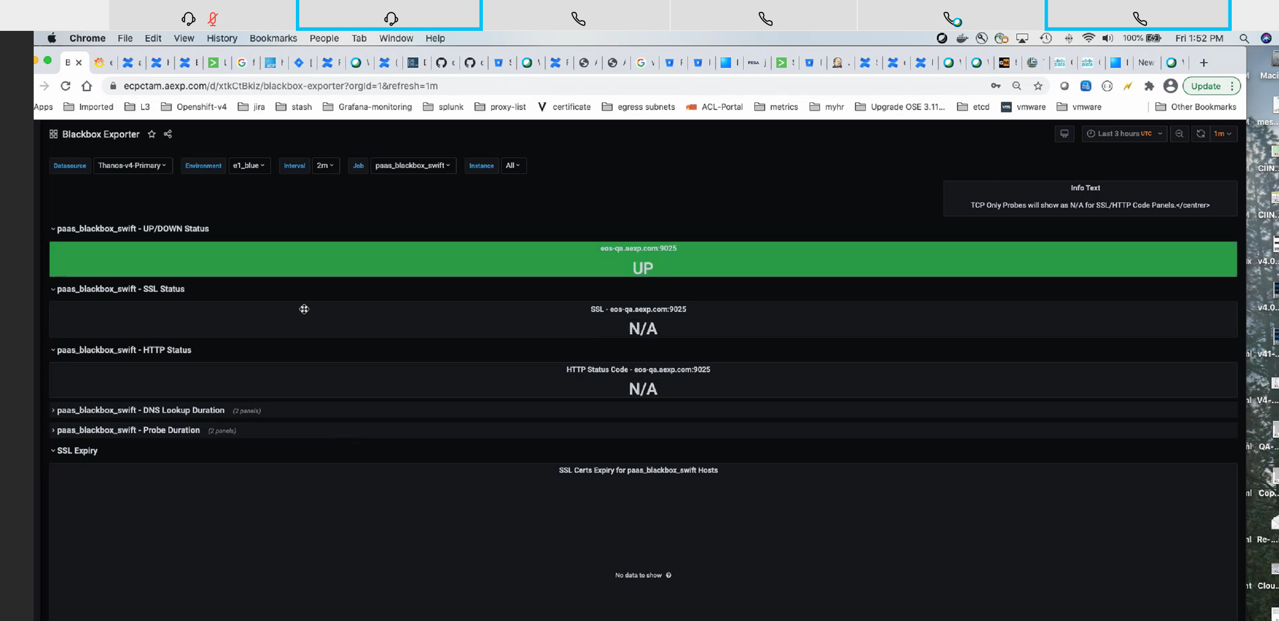

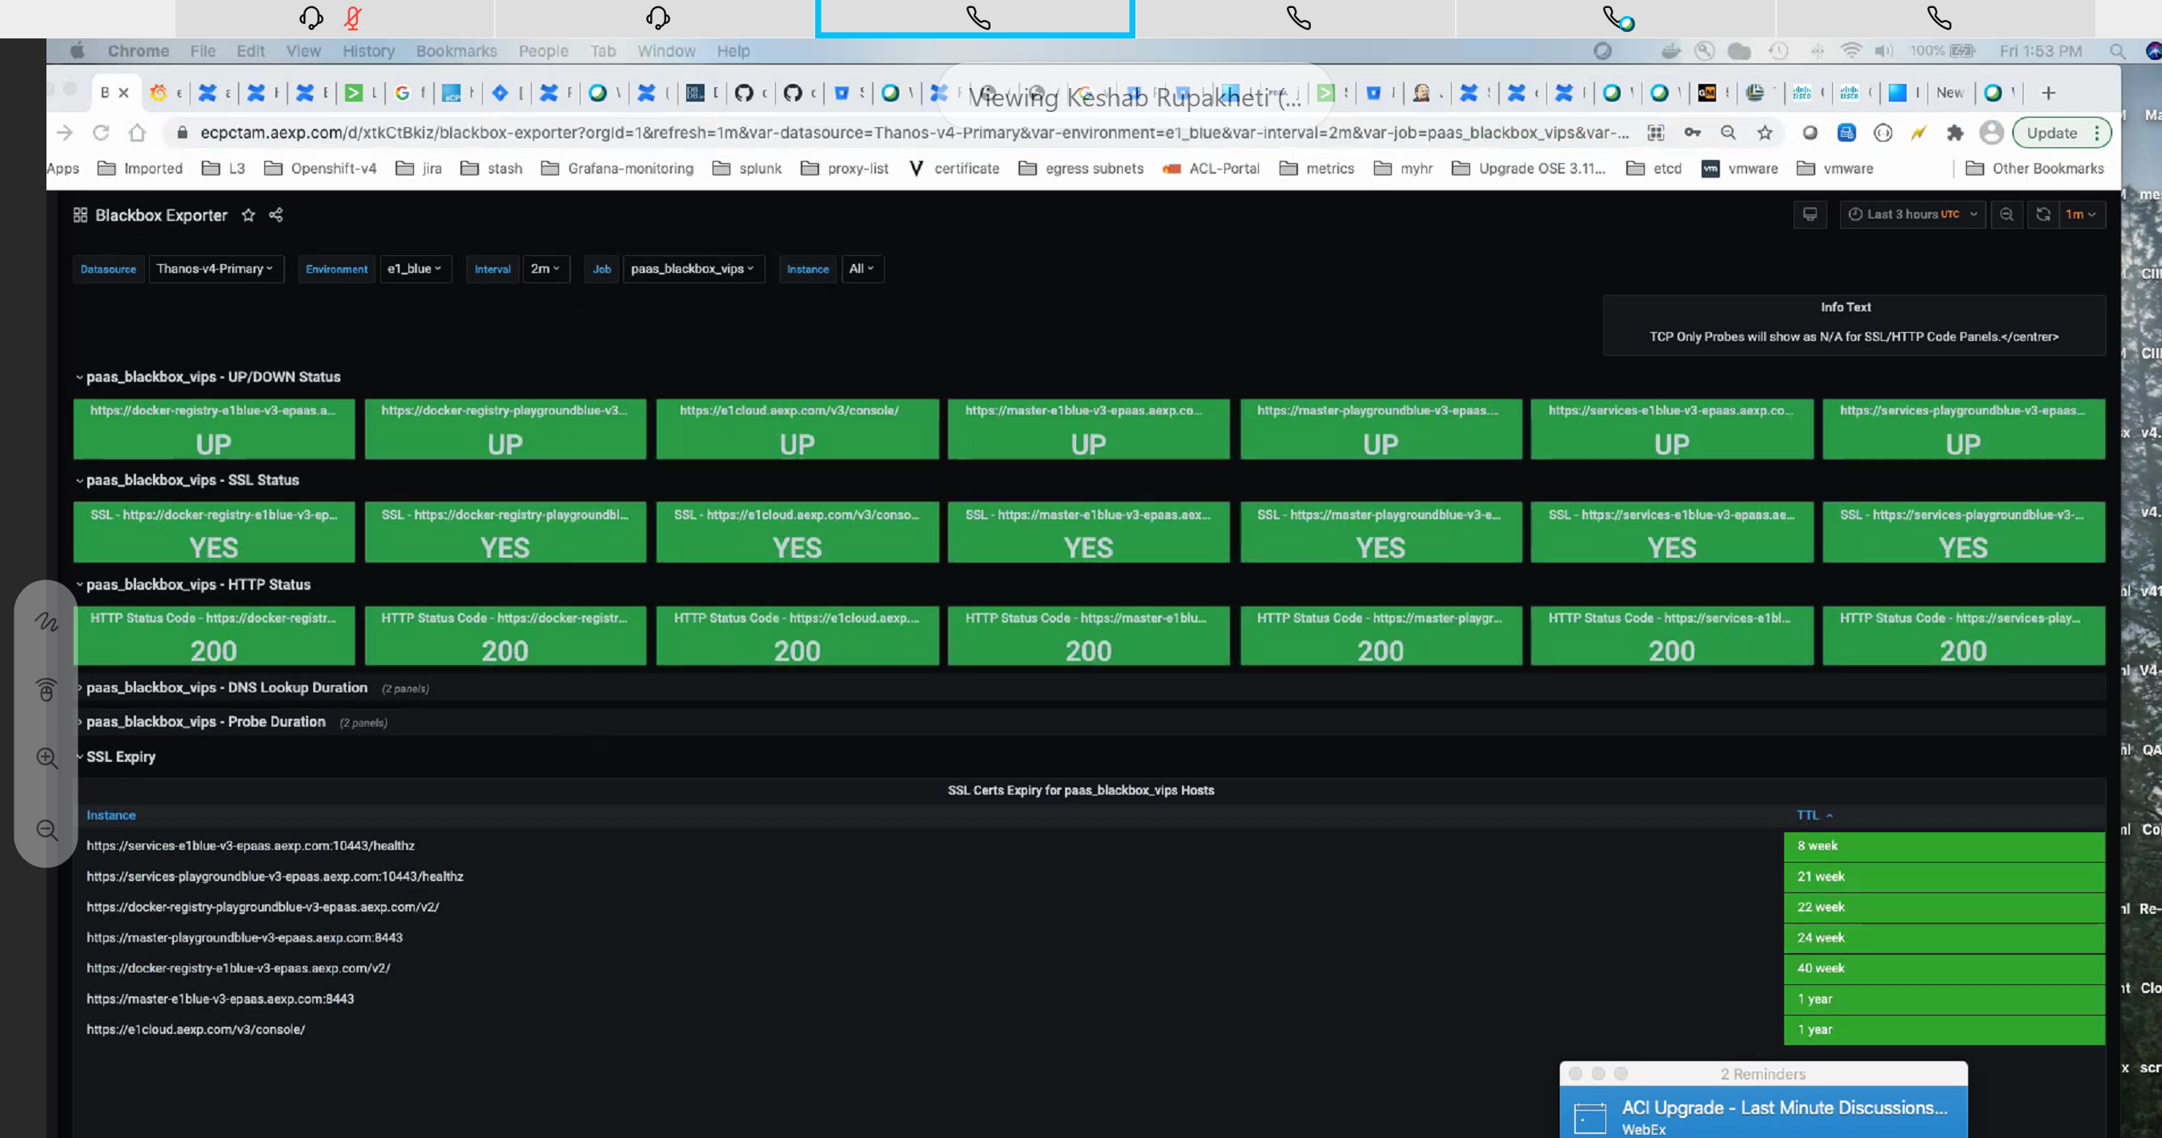

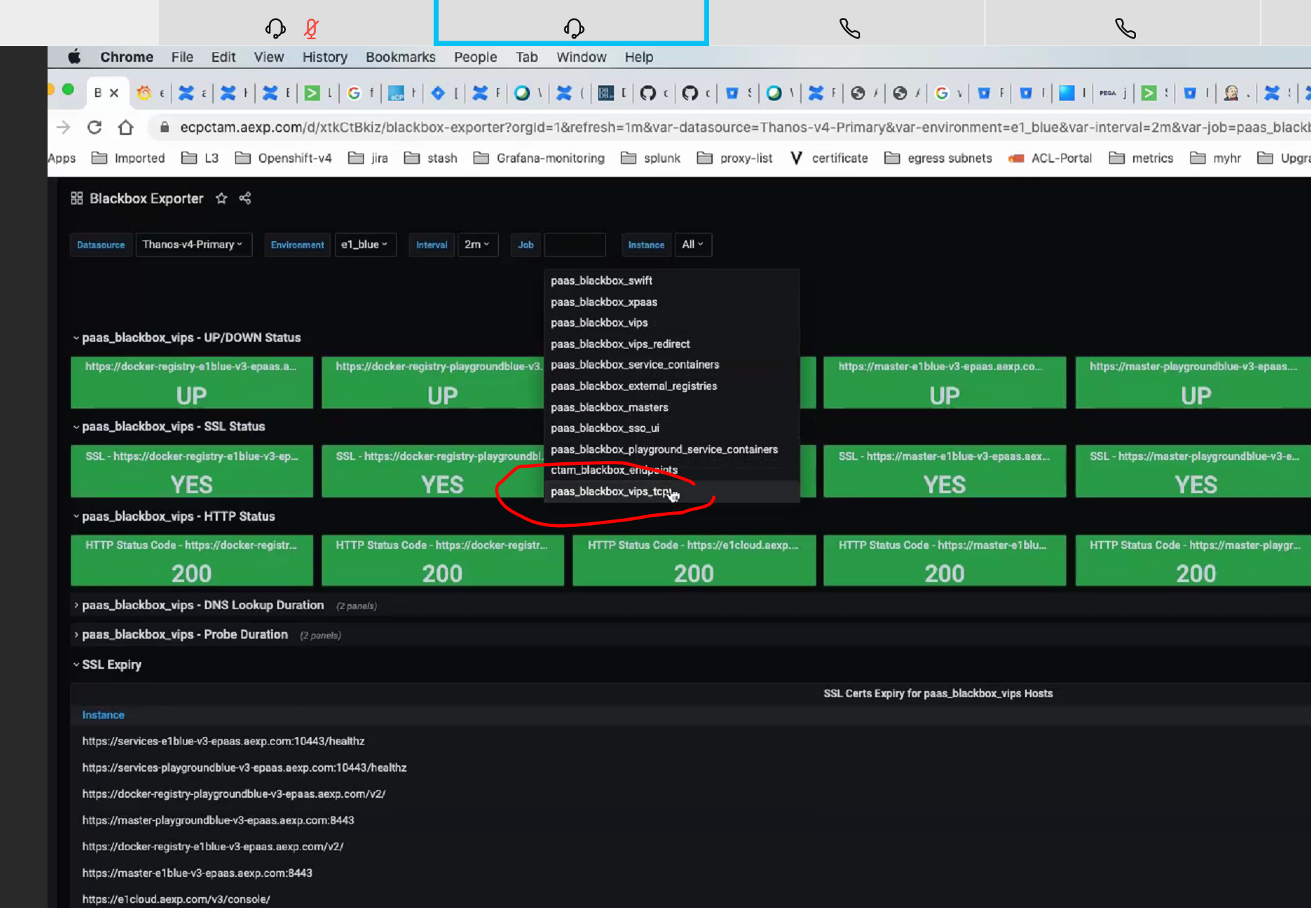

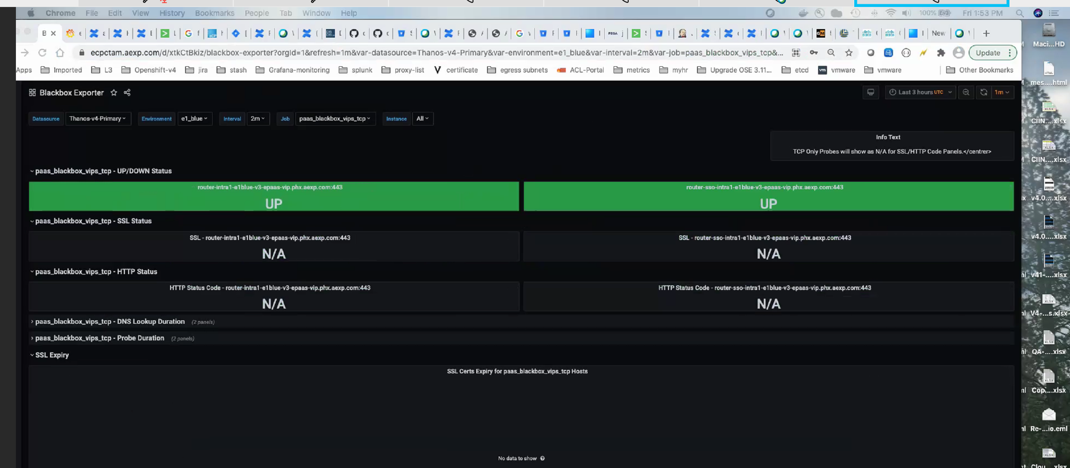

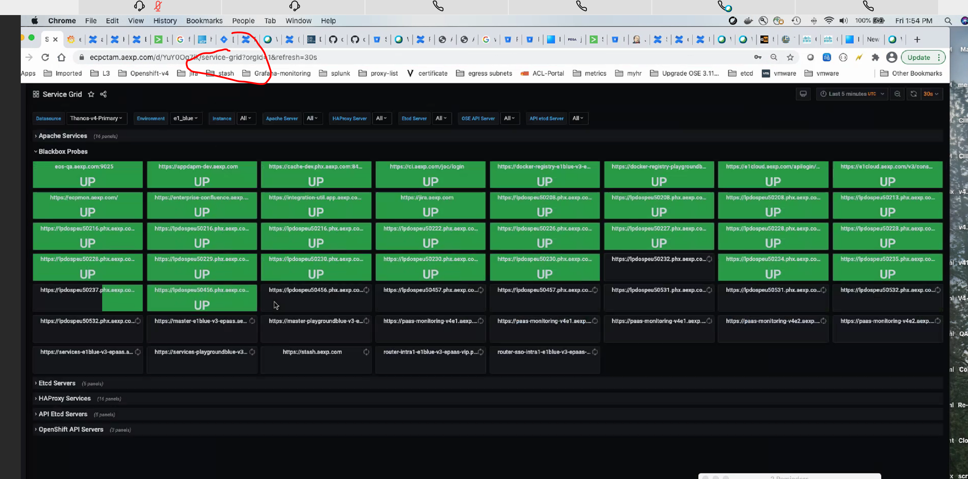

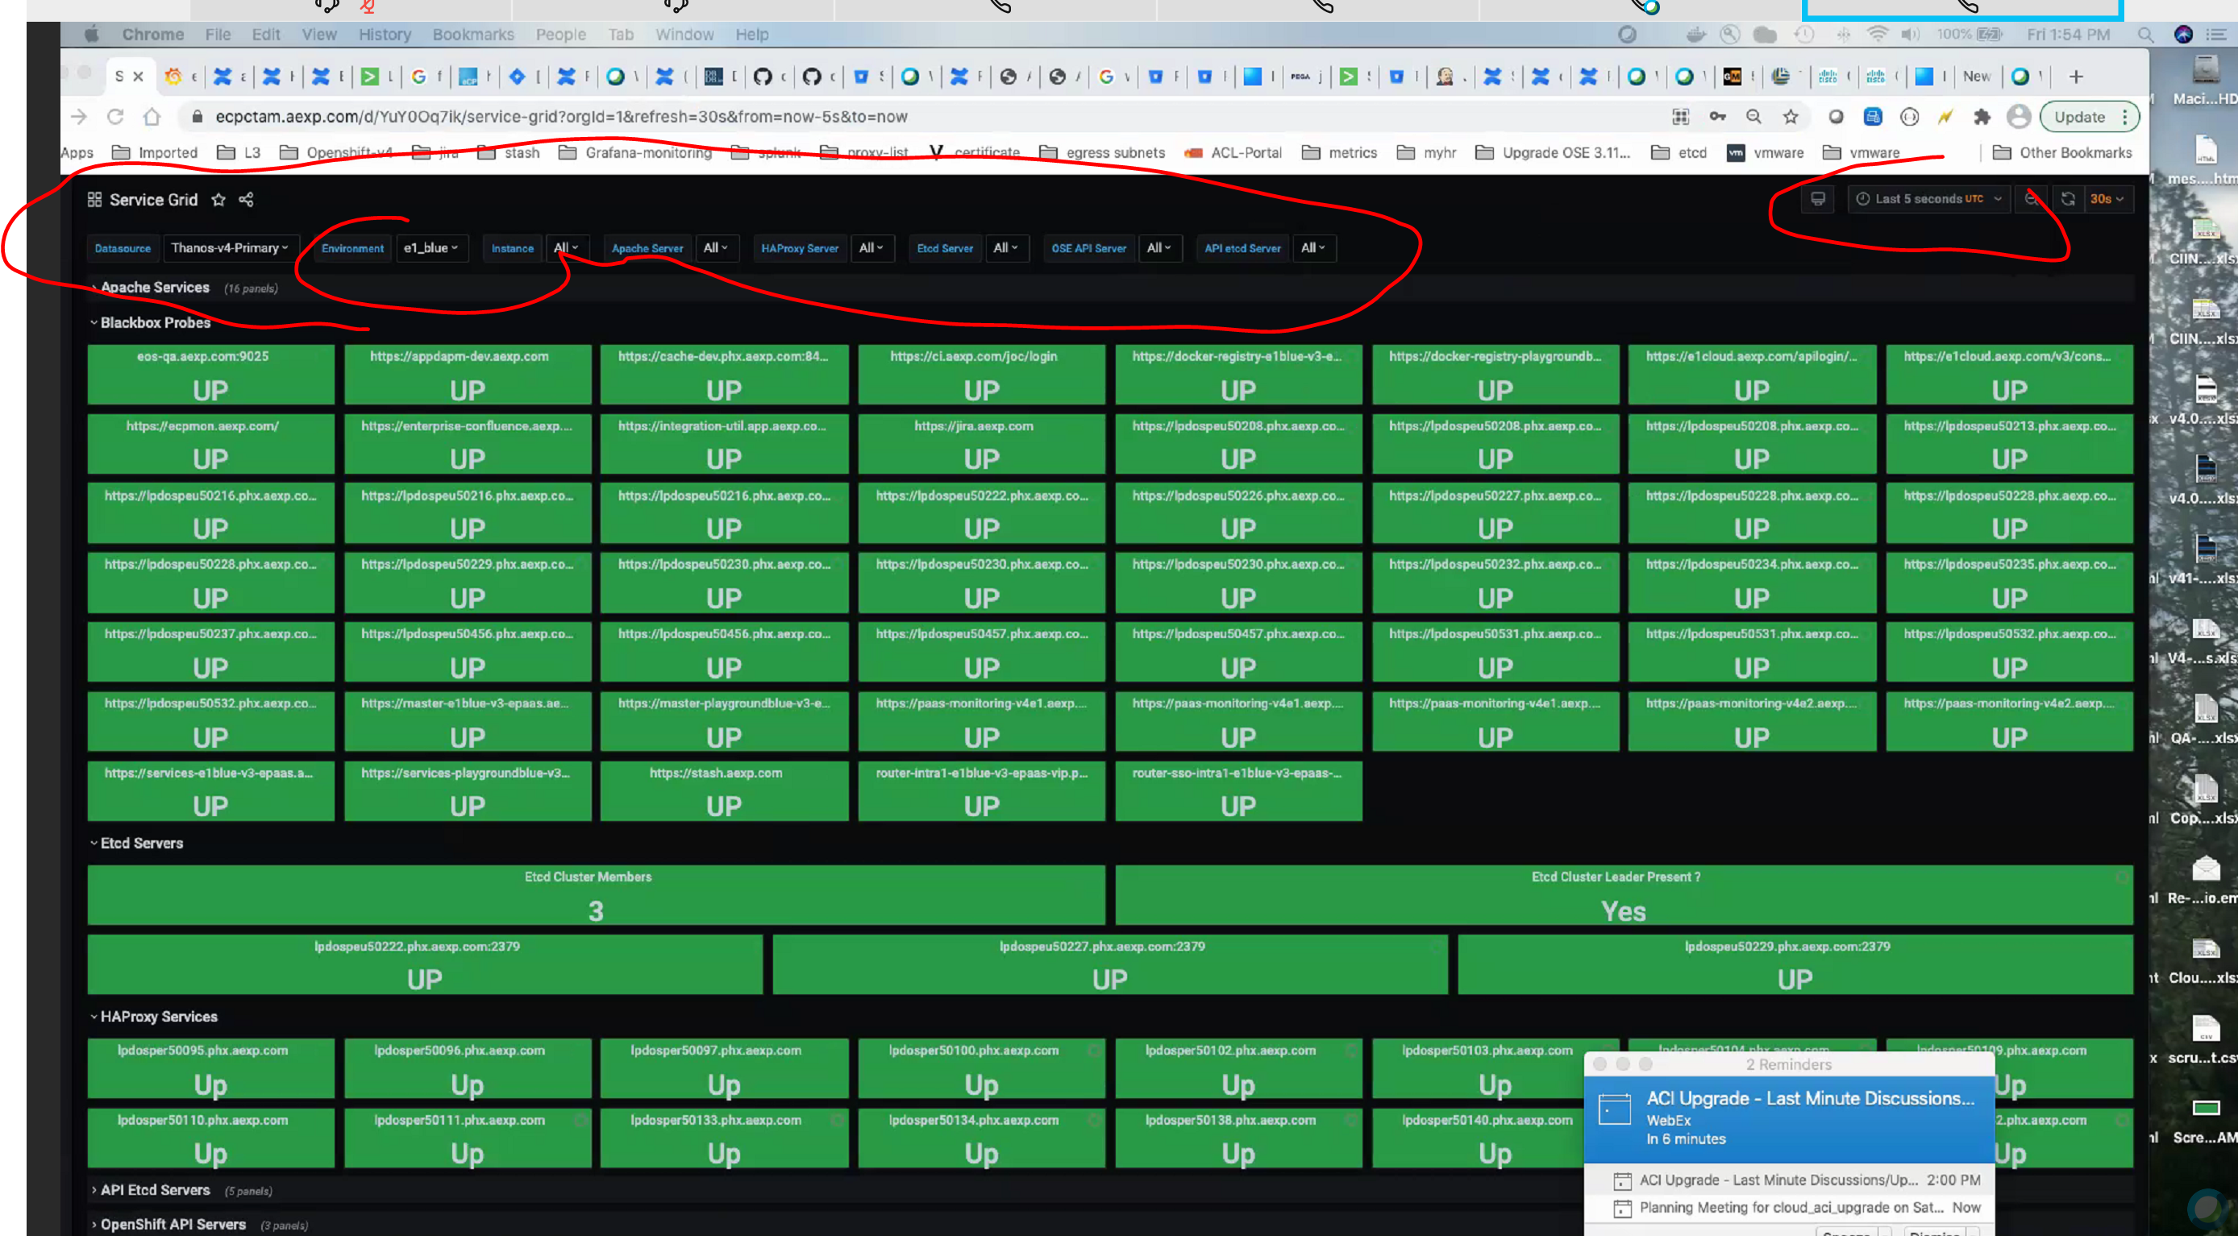

<https://paas-monitoring-v4e1.aexp.com/grafana/d/cL1_9dYmk/paas-service-status?orgId=1&refresh=1m>

<https://paas-monitoring-v4e1.aexp.com/grafana/d/foZ2ywnmz/ose-metrics?orgId=1&refresh=1m>

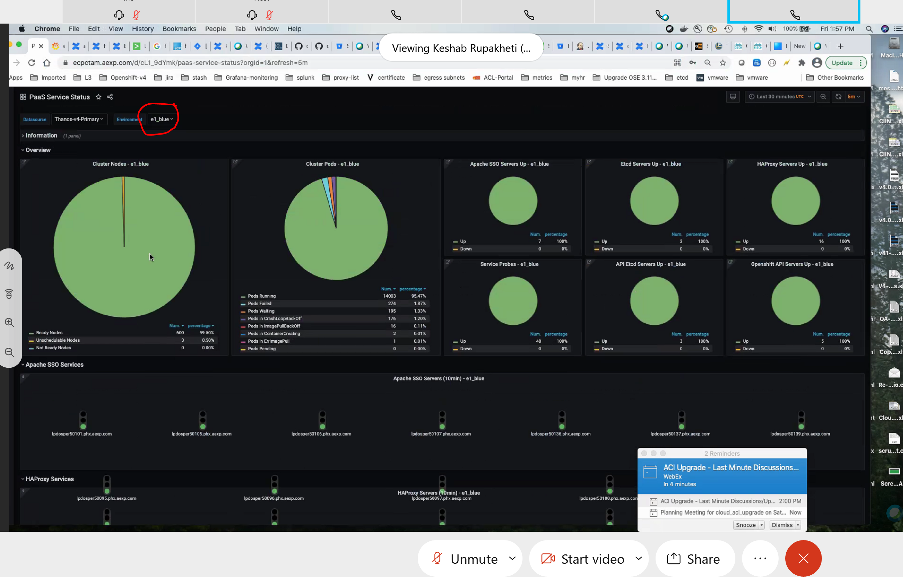

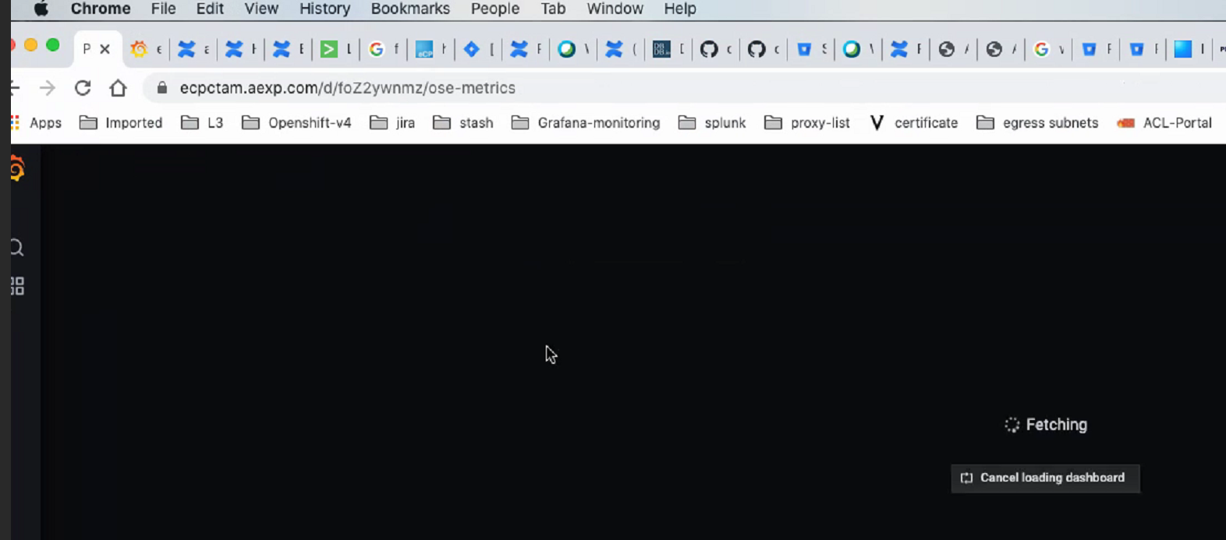

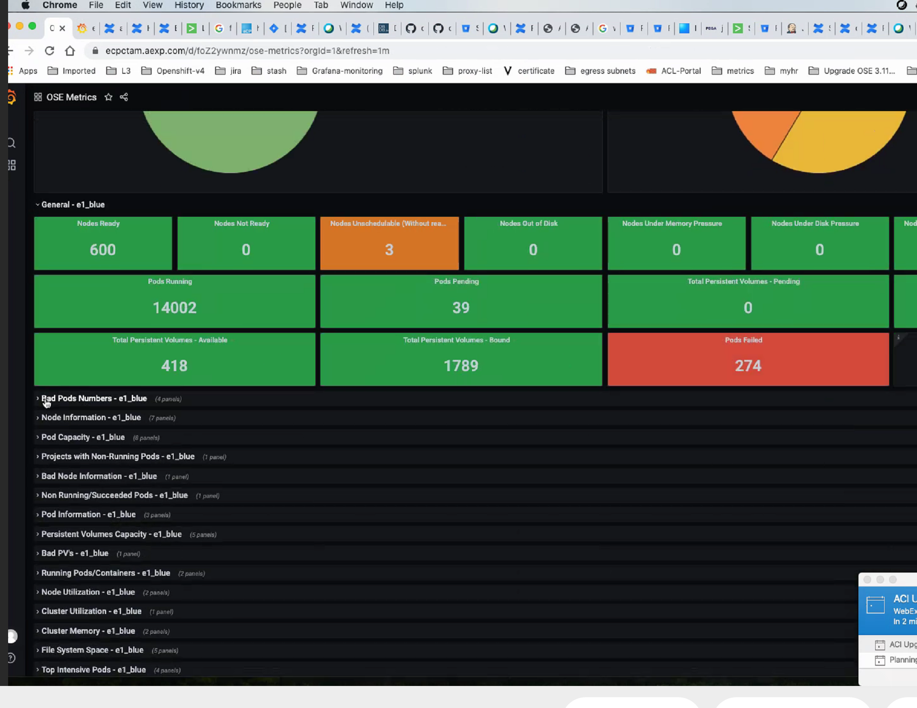

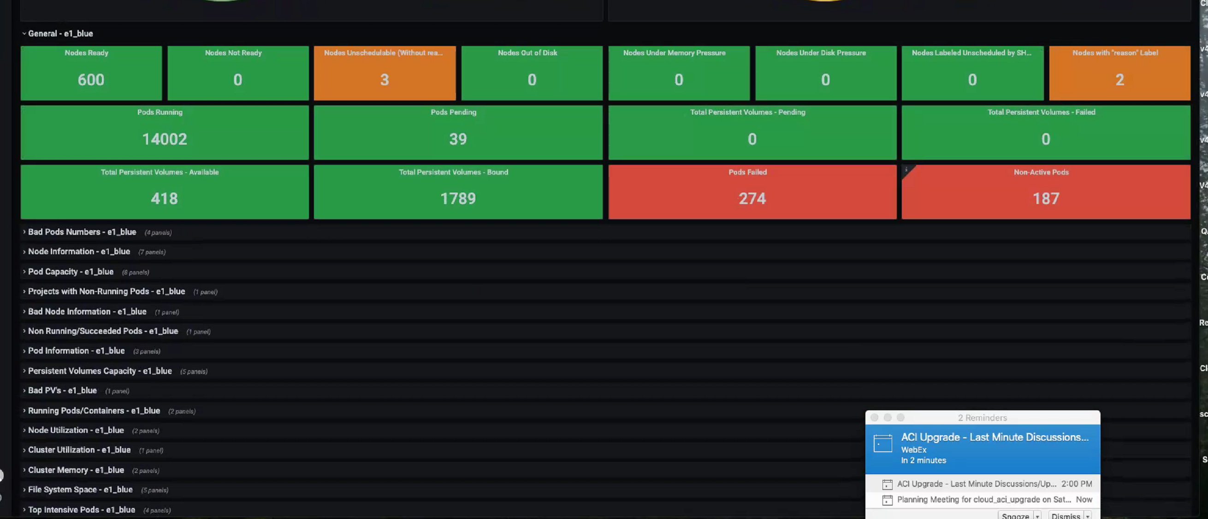

################### All Monitoring url ##############

monitor etcd : https://ecpctam.aexp.com/d/GO1Yd7riz/etcd-dashboard?orgId=1&refresh=5m scroll up down for regions selections for all regions (edited)

monitor : node status ; pod status for all regions : https://ecpctam.aexp.com/d/foZ2ywnmz/ose-metrics?orgId=1&refresh=1m

paas blackbox vips : incluses api,registry, master-vip, consoles https://ecpctam.aexp.com/d/xtkCtBkiz/blackbox-exporter?orgId=1&refresh=1m&var-datasou%5B%E2%80%A6%5D&var-interval=2m&var-job=paas_blackbox_vips&var-instance=All (edited)

monitor router vips status : https://ecpctam.aexp.com/d/xtkCtBkiz/blackbox-exporter?orgId=1&refresh=1m&var-datasou[…]-interval=2m&var-job=paas_blackbox_vips_tcp&var-instance=All

service grid : https://ecpctam.aexp.com/d/YuY0Oq7ik/service-grid?orgId=1&refresh=30s&from=now-5s&to=now

paas service status: https://ecpctam.aexp.com/d/cL1_9dYmk/paas-service-status?orgId=1&refresh=5m

https://ecpctam.aexp.com/d/foZ2ywnmz/ose-metrics?orgId=1&refresh=1m